ICP5-SHASHANK ARVA-700756617

1. Implement Naive Bayes method using scikit-learn library

Use dataset available with name glass

Use train_test_split to create training and testing part

Evaluate the model on test part using score and

classification_report(y_true, y_pred)

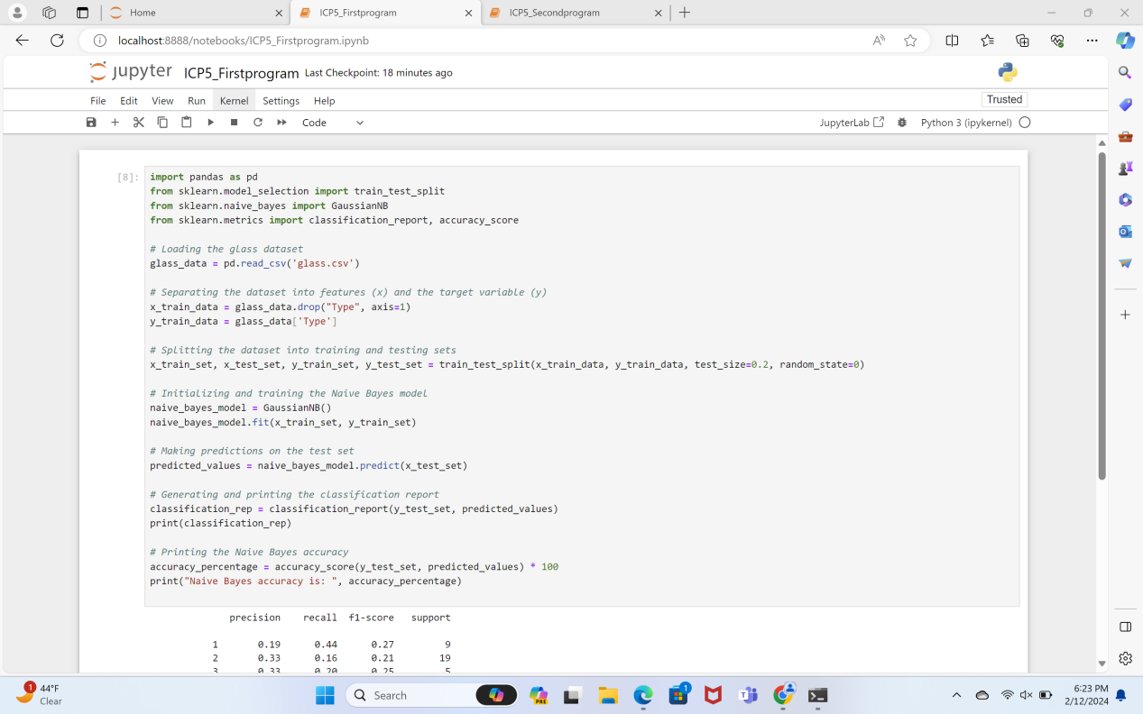

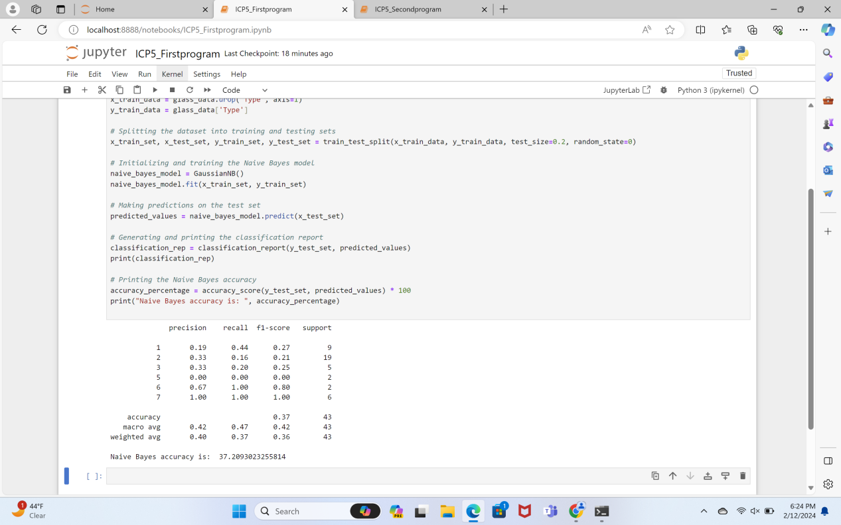

2. Implement linear SVM method using scikit library

Use the same dataset above

Use train_test_split to create training and testing part

Evaluate the model on test part using score and

classification_report(y_true, y_pred)

